GRMAvxbfgfgfgfgfgfgfgfgfgfgfgfgfgfgfgh
Governance Module 03.06.2024

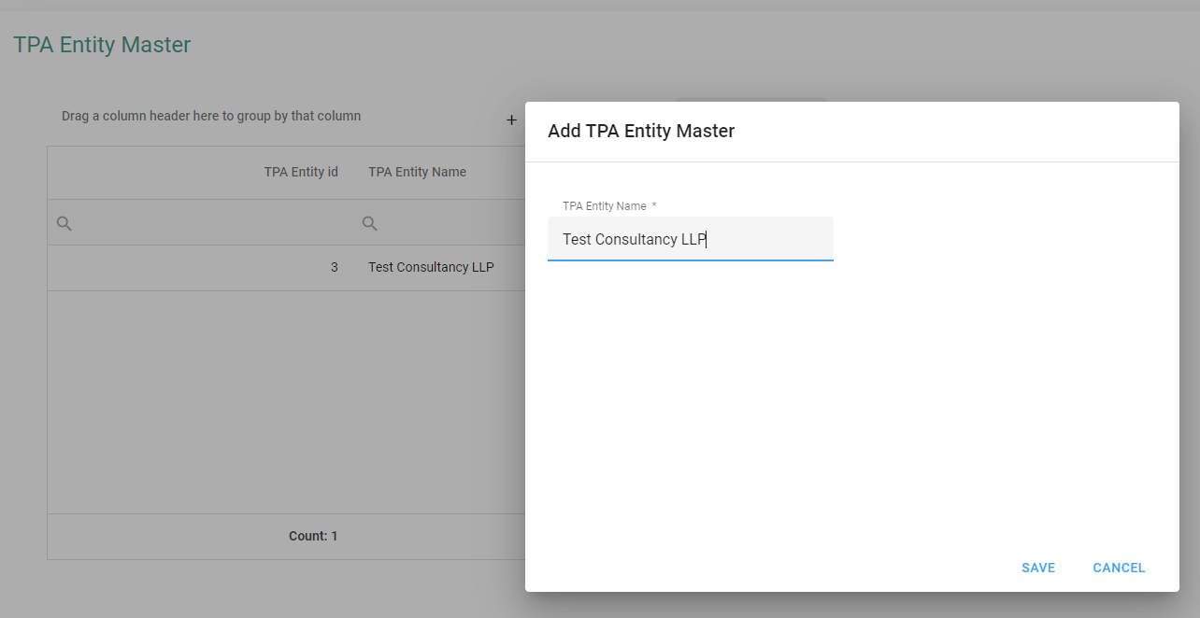

There is no place to add more details of TPA Entity just like, TPA Entity Description, Address, City, State, Country

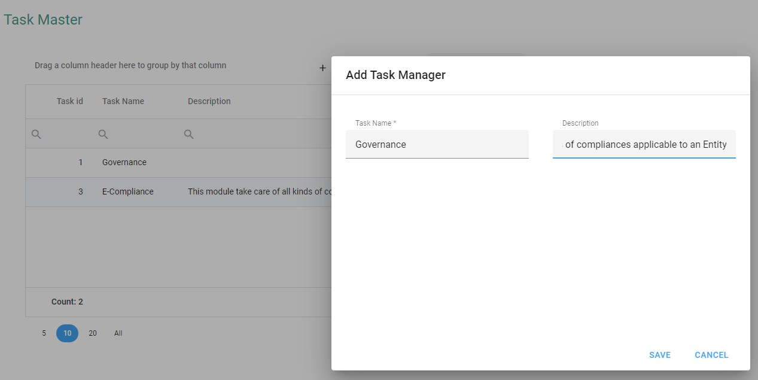

Header should say, “Edit Task Master”

Auto Wrapping not working here

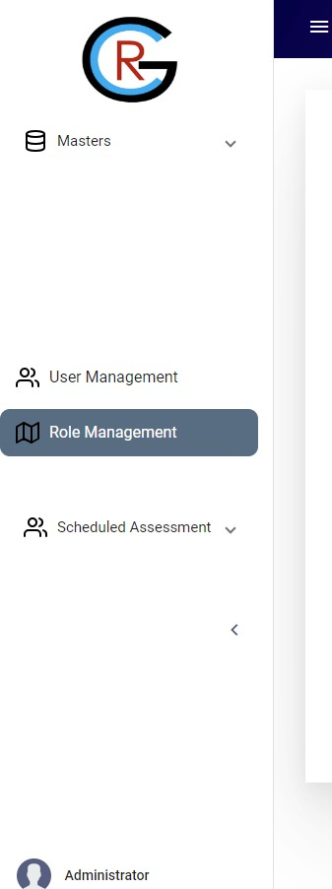

Still the problem of Scroll Bar has not been fixed.

Why this white space / gap is coming?
Not working, Sometimes it works, sometimes not
All menu options should auto align based on the role mapped.

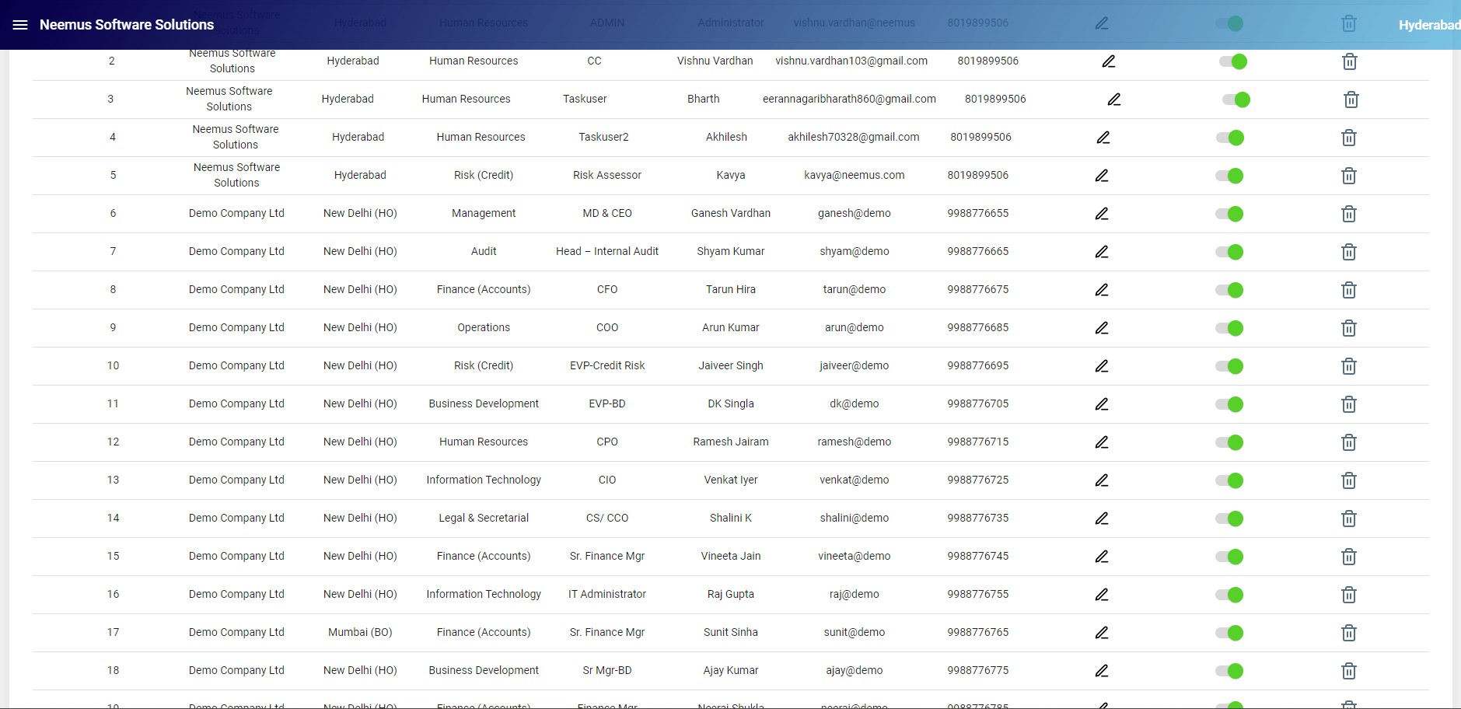


Header should remain fixed while scrolling

The problem of Scroll
Bar has not been fixed.

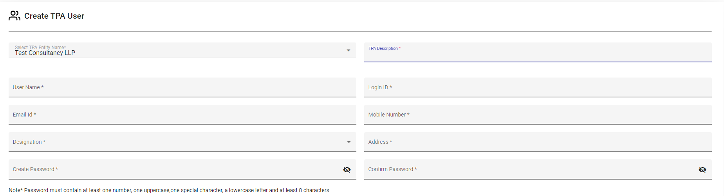

This should be available at the time of creating TPA Entity (ref Slide 2)

This should be available at the time of
creating TPA Entity (ref Slide 2).
Should not be Mandatory

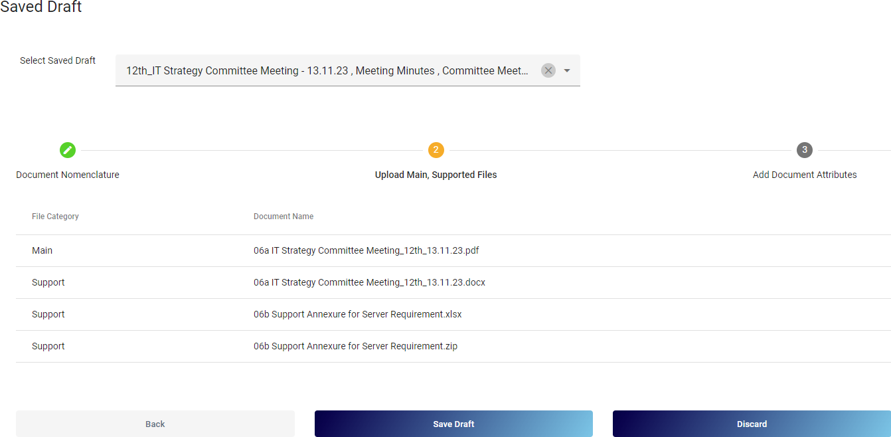

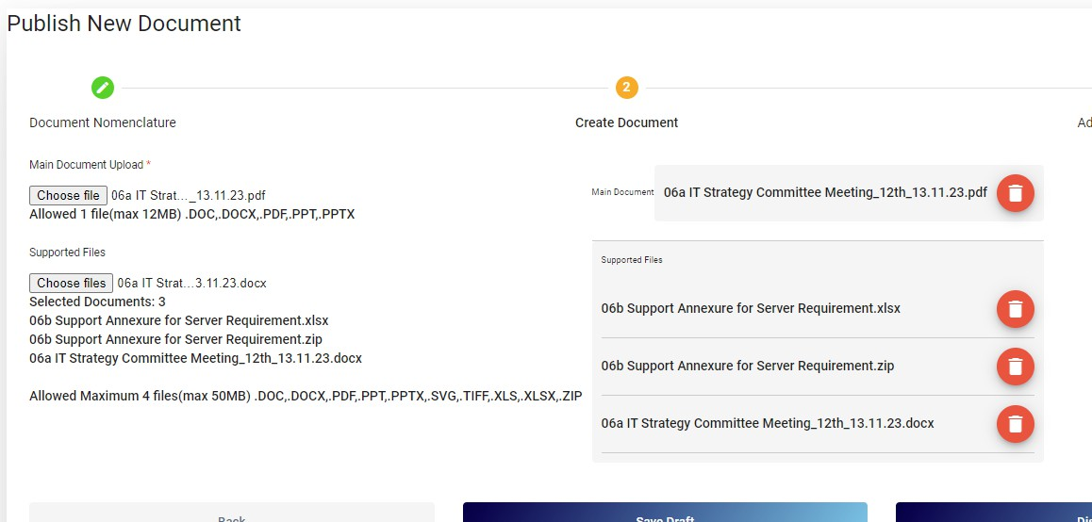

Option to Edit/ Remove/ Add more files (upto the limit set) is NOT available.
Similar screen should open

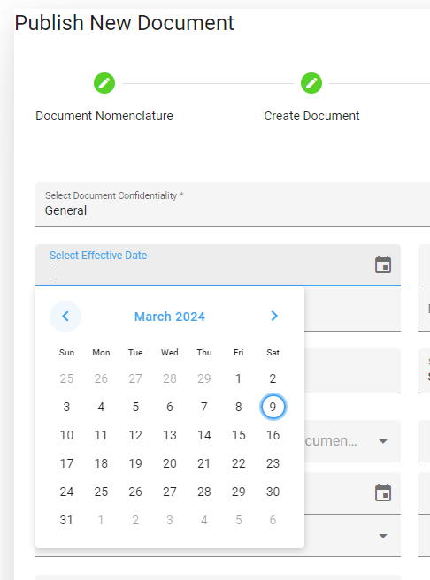

Not able to change dates

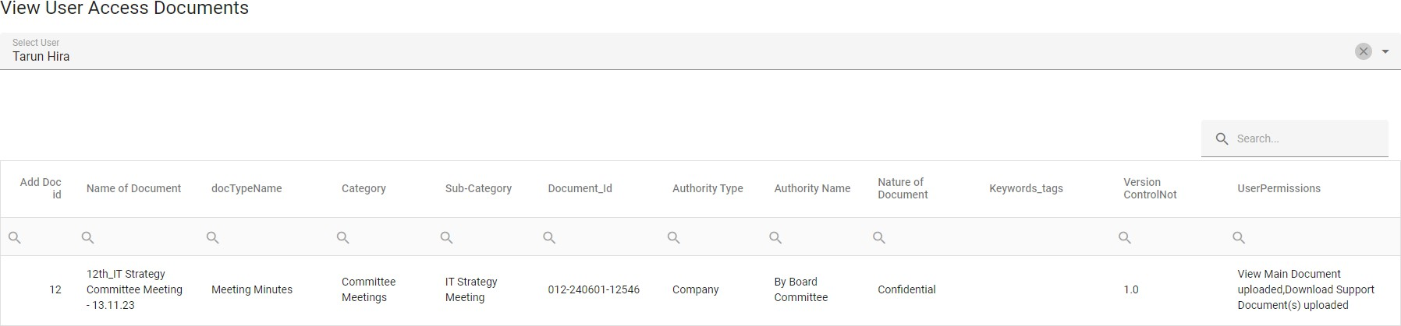
Change in permission rights not changed/ updated

